**Voltage Protection Circuit with Adjustable Threshold Voltage**

**Project Report**



**Spring 2023**

**CSE-206L Electronic Circuits Lab**

Submitted by:

**Shahzad Bangash(21PWCSE1980),**

**Suleman Shah(21PWCSE1983),**

**Ali Asghar(21PWCSE2059)**

Class Section: **C**

“On my honor, as student of University of Engineering and Technology, I have neither given nor received unauthorized assistance on this academic work.”

Submitted to:

**Engr. Abdullah Hamid**

Date:

**July 7, 2023**

**Department of Computer Systems Engineering**

**University of Engineering and Technology, Peshawar**

**Abstract:**

The purpose of this project is to design and implement a voltage protection circuit that safeguards sensitive electronic circuits from excessive\low voltage levels. The circuit incorporates a potentiometer to set the threshold voltage, which controls a transistor and relay to disconnect the load whenever the voltage exceeds the set limit. This report provides a detailed explanation of the circuit's design, components used, and its functionality.

**Introduction:**

Sensitive electronic circuits are susceptible to damage when exposed to high/low voltage levels. It is essential to protect these circuits from overvoltage/undervoltage to ensure their longevity and proper functioning. The voltage protection circuit presented in this project report aims to provide a reliable solution by monitoring the voltage level and disconnecting the load when the voltage exceeds a predetermined threshold.

**Components Used:**

* Resistors (R1, R2, R3, and R4): To create voltage dividers and generate reference voltage.
* Transistor (Q1): To control the relay based on the input voltage.
* Relay (RL1): To disconnect the load from the power source when activated.
* Diodes (D1, D2 and D3): To control current direction.
* LED’s (D4, D5 and D6): To display output.
* Potentiometer (AV1): To adjust the threshold voltage.
* Input Jacks (J1 and J2): To give input and output voltage.

**Description of Components:**

1. **Resistors:**

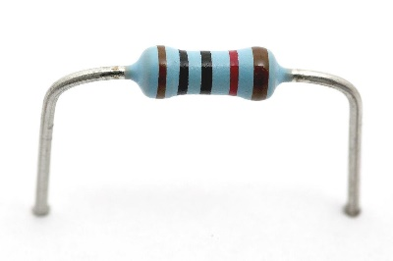Resistors are passive electronic components that impede the flow of electric current in a circuit. They are primarily used to control the amount of current or voltage in a circuit, divide voltages, set biasing conditions for active components, and limit current to protect components. Resistors are characterized by their resistance, which is measured in ohms (Ω). The resistance value determines the amount of opposition offered to the flow of current. Resistors come in various types, such as carbon film, metal film, and wire-wound, each with specific properties suitable for different applications.

Figure 1-1: A thin-film Resistor

1. **Transistor:**

A transistor is an active semiconductor device that amplifies or switches electronic signals and electrical power. It consists of three layers of semiconductor material, namely the emitter, base, and collector. Transistors are widely used in electronic circuits as amplifiers, oscillators, and switches. The most common types of transistors are bipolar junction 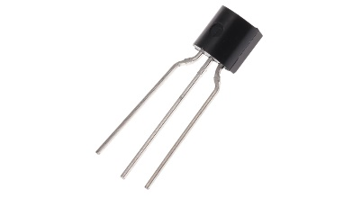transistors (BJTs) and field-effect transistors (FETs). Transistors can be operated in different configurations, such as common-emitter, common-base, and common-collector for BJTs, or as enhancement mode or depletion mode for FETs, depending on the desired functionality.

Figure 1-2: BJT Transistor

1. **Relay:**

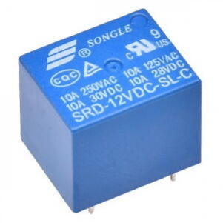A relay is an electromechanical device that operates as an electrically controlled switch. It consists of a coil, an armature, and one or more sets of contacts. When a current flows through the coil, it generates a magnetic field that attracts the armature, causing the contacts to change their position. Relays are commonly used to control high-power or high-voltage circuits with the help of a low-power signal. They provide electrical isolation between the control circuit and the controlled circuit, making them useful for applications where high voltage or current needs to be switched or controlled by a low-voltage or low-current signal.

Figure 1-3: 12VDC SPDT Relay

1. **Diodes:**

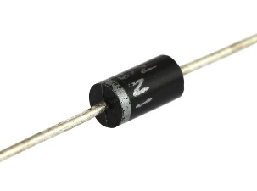Diodes are electronic components that allow current to flow in one direction while blocking it in the opposite direction. They are made of semiconductor materials, typically silicon or germanium. The most common type of diode is the rectifier diode, which converts alternating current (AC) to direct current (DC) by allowing the current to flow in one direction only. Diodes also find applications in voltage clamping, signal modulation, and as protection devices against voltage spikes. Diodes are characterized by their forward voltage drop and maximum reverse

voltage rating.

Figure 1-4: Silicon Diode

1. **LED (Light-Emitting Diode):**

LEDs are specialized diodes that emit light when a current passes through them. They are widely used for various applications, including indicator lights, display panels, and lighting fixtures. LEDs are highly efficient, durable, and available in different colors. They have become popular as a replacement for traditional incandescent and fluorescent lighting due to their energy efficiency and long lifespan. LEDs emit light when electrons recombine with electron holes in the semiconductor material, producing photons in the process.

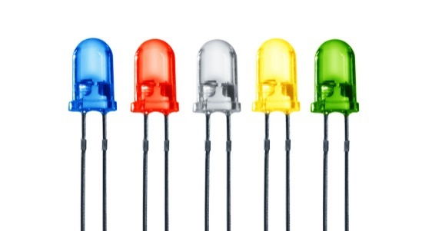

Figure 1-5: Different Color LED’s

1. **Potentiometer:**

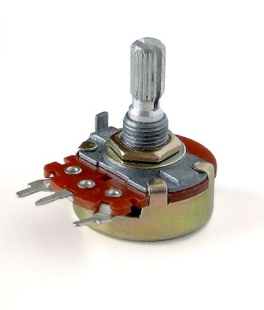A potentiometer, also known as a variable resistor or pot, is a three-terminal resistor with an adjustable resistance. It consists of a resistive element and a movable contact (wiper) that can be adjusted along the resistive track. Potentiometers are used to control voltage or current in a circuit by varying the resistance. They provide a user-adjustable means of setting parameters such as volume, brightness, or gain. Potentiometers are commonly used in audio equipment, lighting controls, and instrumentation to provide precise and variable control over electrical quantities.

Figure 1-6: Potentiometer

**Working Principle:**

This circuit works on the principle of voltage division. First of all, we make a voltage divider network to give input voltage to an NPN transistor which is used to drive a 12V Relay. Relay disconnect the output circuit from the input voltage whenever the input voltage exceeds the threshold voltage. Threshold Voltage is set using the potentiometer (Using Voltage Divider Network). LED’s are used to indicate the output of the circuit.

**Circuit Operation:**

The circuit operates as follows:

The input voltage is divided across the two resistors (one fixed and one variable). The variable resistor is used to set the threshold voltage for our circuit.

When the transistor is turned on, the relay is energized and the connection to the circuit is cut off. This means that whatever was connected to the output of the circuit will no longer receive the input voltage as it has increased above the threshold.

**Schematic Layout:**

**PCB Layout:**

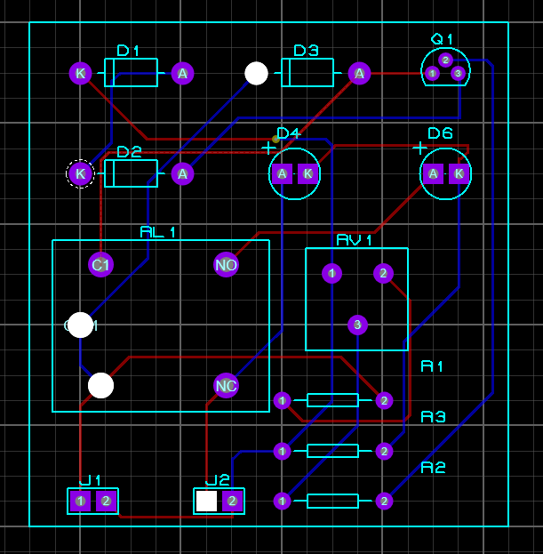

**Conclusion:**

The high voltage protection circuit presented in this project report offers an effective solution to safeguard sensitive electronic circuits from excessive voltage levels. By incorporating a potentiometer to adjust the threshold voltage, users can tailor the circuit to suit their specific requirements. The circuit design and operation have been thoroughly explained, enabling successful implementation of the project. This protection circuit ensures the longevity and reliability of delicate electronic circuits, making it an invaluable addition to any electrical system.

**References:**

https://www.instructables.com/12v-Automatic-Charger-Auto-Cut-OFF/